 | DEPARTMENT OF INFORMATION TECHNOLOGY
 | APPLICATION DEVELOPMENT THEORY III

TUTORIAL 3
TOPICS: |  | Software Engineering and Ethics | DATE DUE: | 7/2/2022
Answer the following questions
- Explain how Software Engineering differs from Software Development.
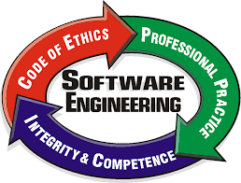

- Examine the principles which guide the behaviour of the Ethical Software Engineer and explain how you would incorporate these principles into your daily practice. https://ethics.acm.org/code-of-ethics/software-engineering-code/

- Examine CPUT’s policies on ethical the behaviour expected of students at this university. You can find this in the Student Handbook. Match these to the Ethical Principles for Software Engineering and list four ways in which you can adhere to both policies in this course.

